2023

Walmart-store

REPORT

a

eng.ibraheem alabed



**Abstract**

Since the world is constantly evolving in all directions, it must keep pace with this development, so we decided to develop a modern sales system that helps users with sales and inventory operations instead of the old manual system that contains many problems that have been solved in this project.

.

CONTENTS

TABLE OF

Chapter 1: Introduction 1

1.1 Overview 2

1.2 Problem Statement 2

1.3 Project objectives 2

1.4 Project outline 3

Chapter 2: Methodology 4

3.2.1 Overview 4

3.2 Feasibility Study 4

3.3 Requirements 5

3.3.1 Functional requirements: 5

1.3.2 Non-functional requirements: 5

3.3.3 Tools 5

3.4 Methodology process 6

Chapter 3: Design Models 6

4.1 Overview 7

4.3 Use Case Diagram 8

4.4 Data flow Diagram 9

4.5 ER Diagram 10

Chapter 4: Experiments and results 11

5.1 Overview 12

5.2 Testing methodologies 17

5.2.1 Unit Testing. 17

5.3 Integration testing 18

Appendix: 18

Rest of figures: 18

5.4 System results 18

Chapter 5: Conclusion 18

6.1 Conclusion 18

6.2 Future Work 19

REFERENCES 20

Appendix: 26

Rest of figures: 26

**List of tables**

Table 1: Summary 7

Table 2: Integration testing 18

**List of figures**

Figure 1: Context diagram 7

Figure 2: Use Case Diagram 8

Figure 3: Data flow Diagram 9

Figure 4: ER Diagram 10

Figure 5: Log in page 12

Figure 6: Create item 12

Figure 7: All item 13

Figure 8: Update item 13

Figure 9: Dashbord 14

Figure 10: Create transaction 14

Figure 11: Schema Database 15

INTRODUCTION

In this project, we worked on developing a modern sales system that aims to help users complete sales and inventory operations with minimal effort and professionalism.

In this project, we studied the problems that users of the system might encounter in order to help them give more accurate and easier solutions.

Our project aims to complete sales and stock inventory of goods, and it also works to reduce errors that can occur in manual sales operations

Our project determines the type of users, whether they are accountants, admins, users, etc., which facilitates work and division of work functions



Ibraheem. walmart Report 2023



MESSAGE FROM

OUR LEADERS

We have dedicated our project work to our families and many friends. A special feeling of gratitude to our beloved parents, who have paved the way of science and knowledge for us and for their words of encouragement and push for tenacity.

We would like to thank our friends and for each person who never left our side and gave us help and support to complete this project and certainly to the target groups of this project, who are pilgrim from everywhere.

Moreover, we need to dedicate our project with a special thanks to our supervisor Mr. Bisharah Estephan, for all the efforts he made for us.

# Chapter 1:introduction

## Overview

This chapter explains the problems with the current system that led us to create a website that addresses these issues, as well as the objectives of the new system and the methodology that will be used.

## Problem Statement

Due to the ineffectiveness of the manual system in counting sales, to reduce the error rate, and to avoid problems in counting the quantities available in the store, the manual system was dispensed with and replaced with modern electronic systems.

## 1.3 Project objectives

This portal will enable us to transfer specialization to achieve several goals, including:

* Reduce time searching for products.
* Know the available quantities of a particular product.
* Reviewing the calculations of the products sold.

## 1.4 Project outline

**Chapter 1:** A summary of the problem to be solved, the objectives of the project to be built, and the action plan with a clarification of its steps.

**Chapter 3:** Feasibility study and methodology used in the project, functional and non-functional requirements.

**Chapter 4:** Show how the system works by a set of diagrams in the easiest and simplest way and show how to use the system.

**Chapter 5:** In this chapter, we will talk about implementation and evaluation. With an explanation of each implementation and how it was implemented

**Chapter 6:** A summary of the project and its future work.

## 2.1 Overview

This chapter discusses tools used to get the work done, our feasibility study, the requirement (functional and non-functional), and the methodology process of how the project is done.

## 2.3 Requirements

### 2.3.1 Functional requirements:

* + - 1. Admin portal:
* Create items.
* Create transaction.
* Edit profile.
* Create user.
* See all items.
* See all transactions.
* Edit/delete items.
* Edit/delete transactions.
* Edit/delete users.
  + - 1. Seller portal:
* Create transaction
* Edit/delete transaction

2.3.1.3Accountant portal :

* Edit/delete transaction.
* See all transaction.

2.3.1.4 Procurement portal:

* Create items.
* Edit/delete items.
* See all items.

### Non-functional requirements:

1. Platform usability:

Our project was concerned that its content is clear and brief because there is no difficulty in reaching any required goal.

1. Simple navigation:
2. Work on the search base in three steps.
3. Creating for users with different cognitive processing, or interests.
4. Authentication:

In this system, we have always used unique email addresses, login information, and username for each user.

1. Security:

Password encryption by password hash.

### 2.3.3 Tools

* Visual studio code
* XAMMP
* PHPmy Admin
* Drow.io Diagram
* Google (Meeting, Translate)
* Office 365(Word, PowerPoint)
* Post man

Chapter 3: Design Models

## 3.1 Overview

In this chapter, we are talking about how to design and build relationships between system components by using sous diagrams such as the context diagram, the use case diagram, data flow diagram, ER diagram.

3.2 Context diagram

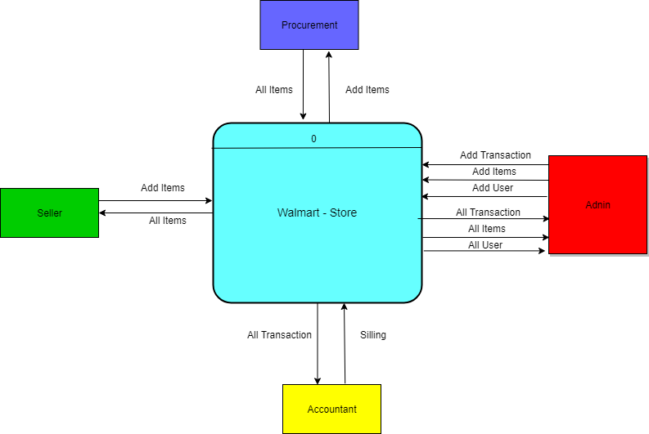

Figure 5: Context diagram

## 3.3 Use Case Diagram

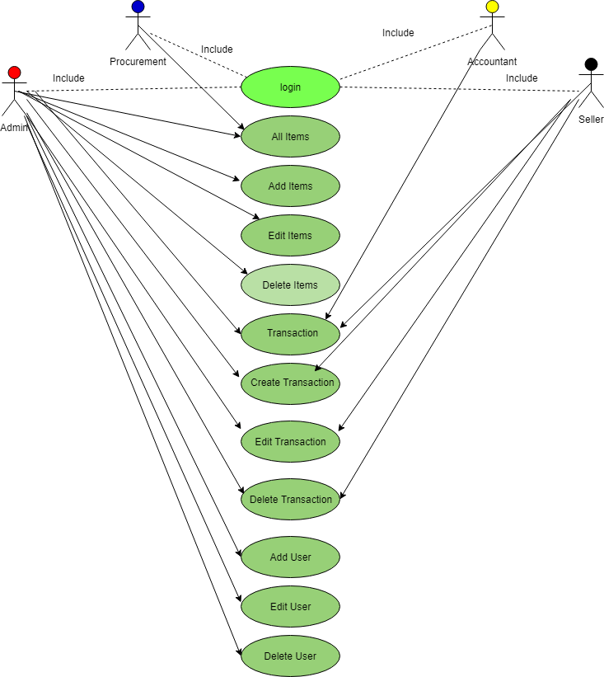

Figure 6: Use Case Diagram

## 3.4 Data flow Diagram

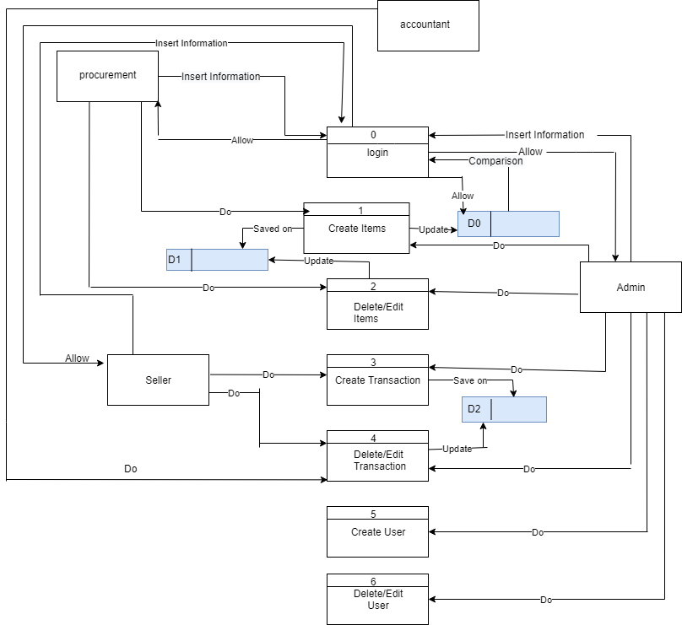

Figure 7: Data flow Diagram

## 3.5 ER Diagram

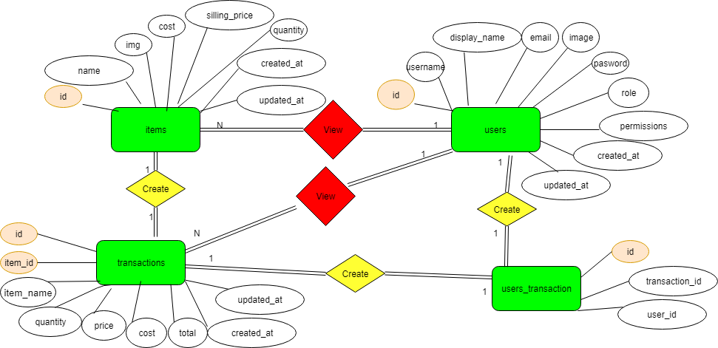

Figure : ER Diagram

# Chapter 4: Experiments and results

# Chapter 2: Methodology

## 4.1 Overview

In this chapter, we will talk about how we test the system with the intent to find whether it satisfies the specified requirement or not.

## 4.2 Testing methodologies

The tests will be divided into three units of tests.

### 4.2.1 Unit Testing.

Three types of units are included, the first for the **Login Page**, the second for the **Create items**, and the third for the **Admin portal**.

#### 4.2.1.1 Login Page

It was checked that the data entered in the registration form was saved in Database, and to ensure that the registration and entry laws are applied to the system.

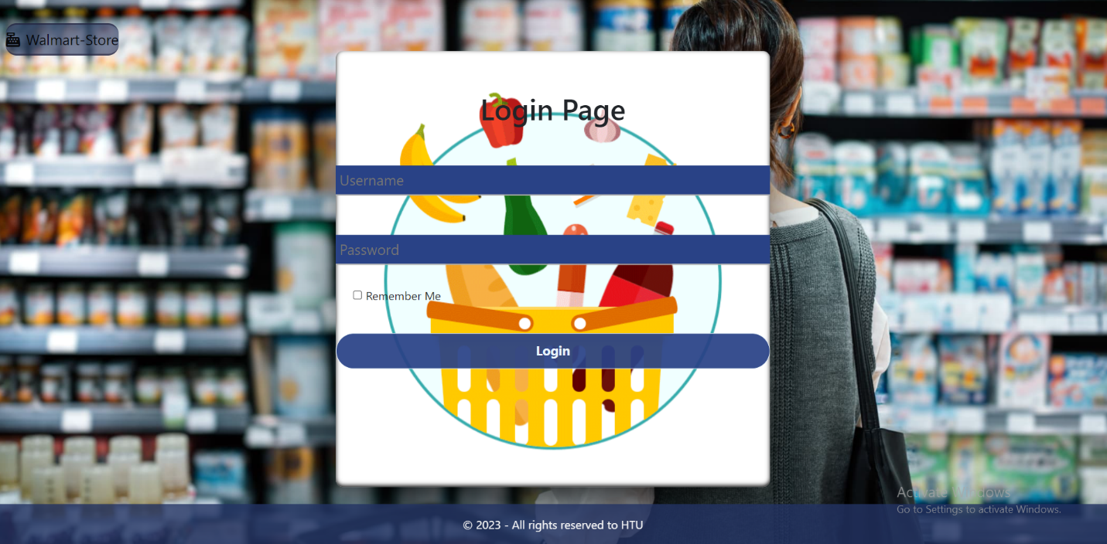

Figure9: Log in page

#### 4.2.1.2 Create items

1. Create item

This page works to create a new item and add it in the data base and display it on the all item page.

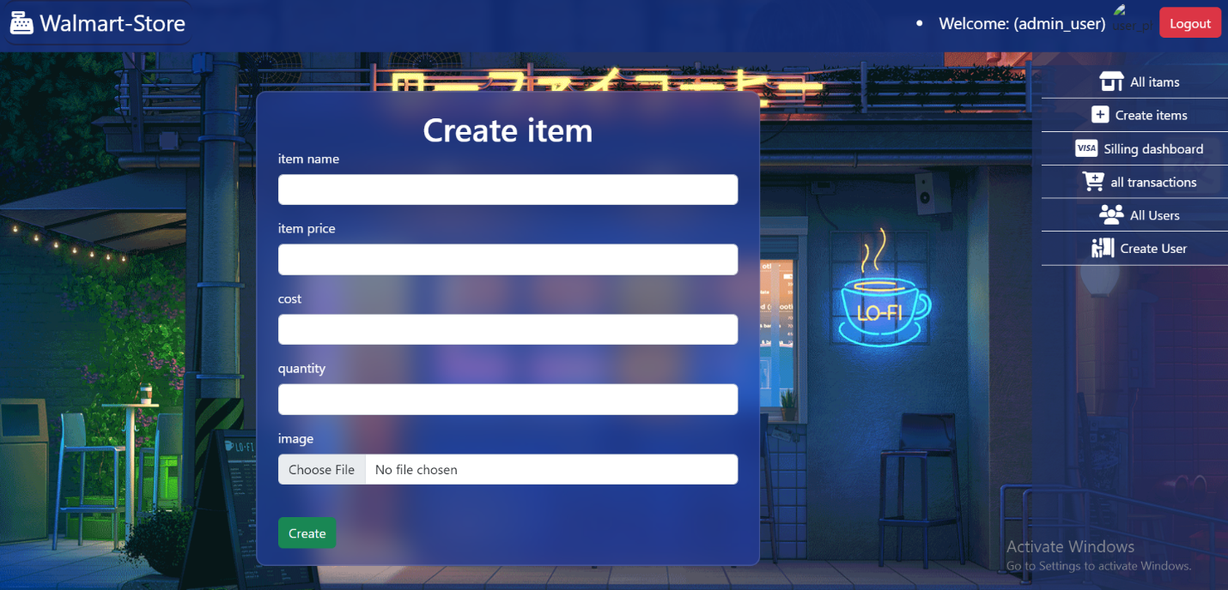

Figure 10: Create item page

1. All Items

This page displays all items that have been created and can be deleted or modified.

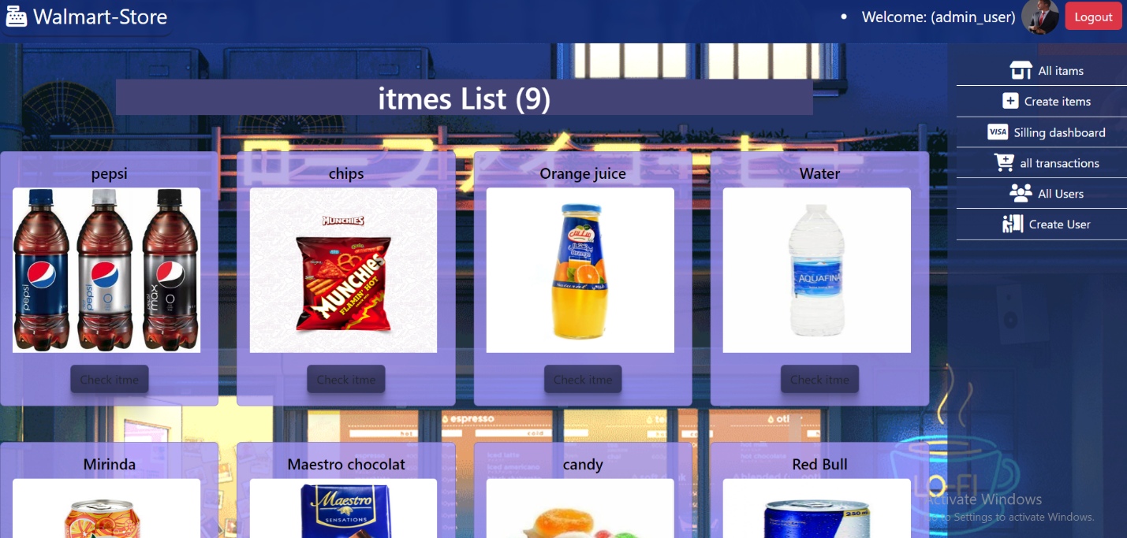

Figure11: All items page

1. Update Item

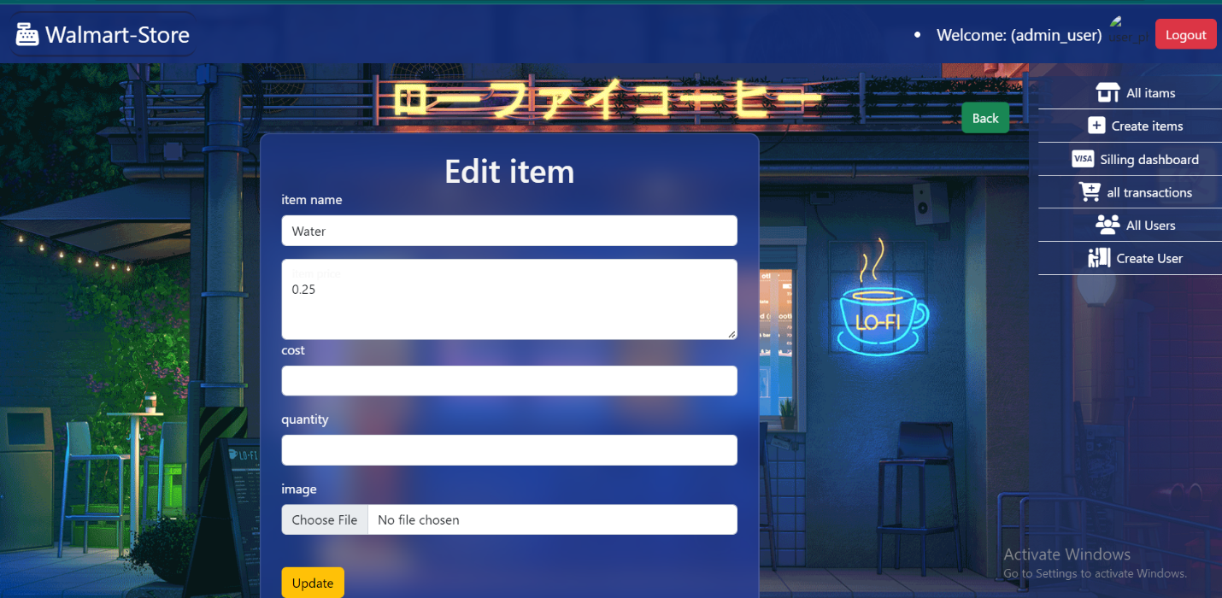

Figure 2: Update Item page

#### 4.2.1.3 Admin portal

1. Dashbord

See the admin dashbord page.

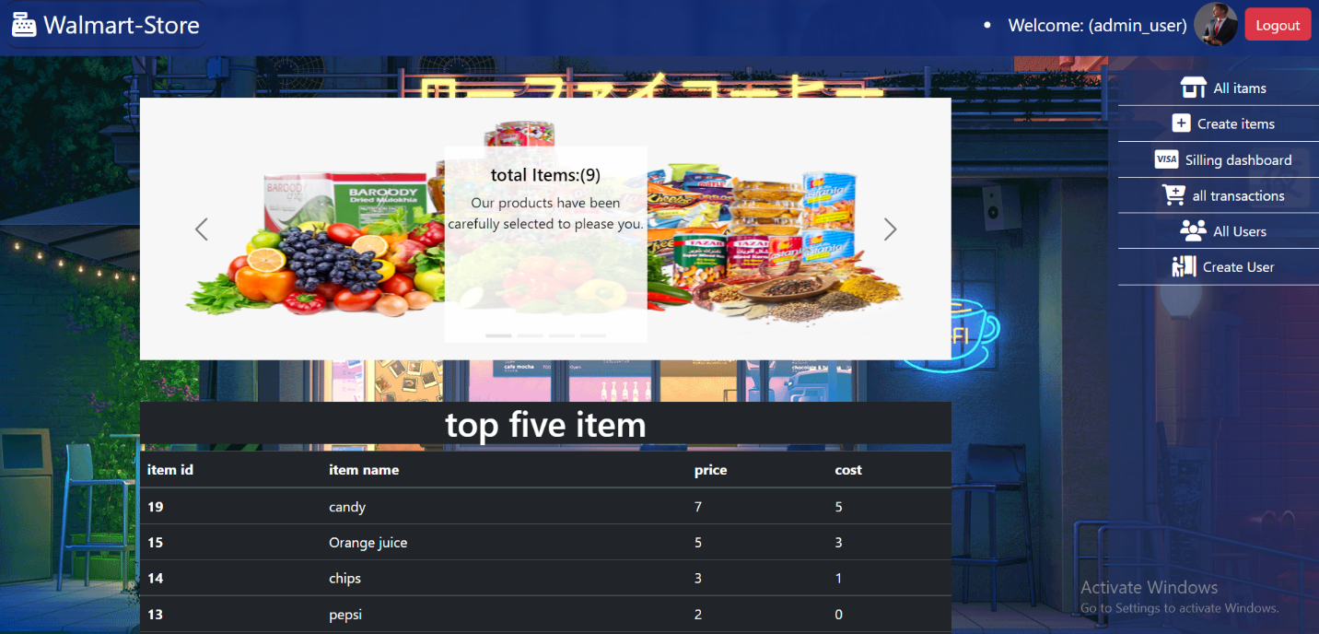

Figure13: Dashbord page

1. Create tranaction

Create any transaction through this page.

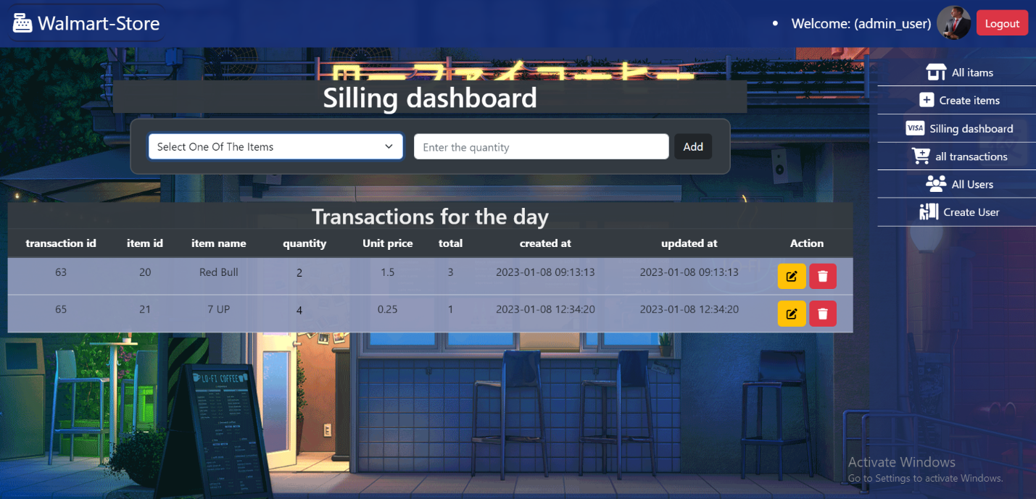

Figure14: Create transaction page

# Appendix:

## Rest of figures:

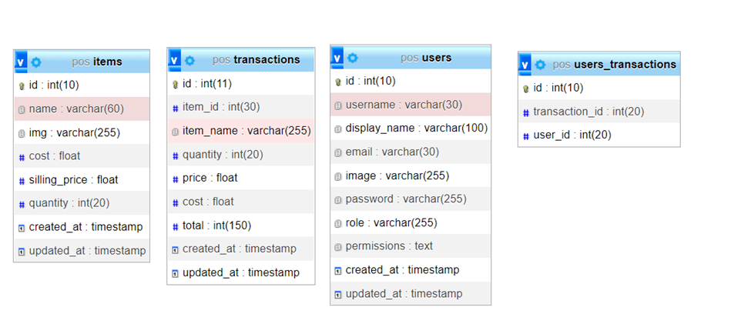

## 4.3 Integration testing

The table that unfortunately shows what errors appeared during the test, and how they were fixed.

|  |  |  |
| --- | --- | --- |
| **Number of unit** | **Error** | **Fixed** |
| **4.2.1.1** | An error in the mixing of powers between the admin and the user. | Determine the mission of each person by defining the permission . |
| **4.2.1.2** | An error in delete item and transaction with some | Set delete method for each page |
| **4.2.1.3** | There were no errors. |  |

Table : Integration testing

## 4.4 System results

After checking all stages of the test, the system is functional and correct.

# Chapter 5: Conclusion

## 5.1 Conclusion

## All stages of the system have been reached, their success verified, and the required goals reached.

## 5.2 Future Work

* Put each item in its own category
* Create a page for users to see the product through which the can purchase.
* Implementation to another language.
* Implement auto plagiarism check.

# REFERENCES

1. <https://www.w3schools.com/>

To use some code for design and some programming issues

1. <https://stackoverflow.com/>

To come up with some solutions to the problems we were facing

1. https://www.javatpoint.com/software-engineering-incremental-model

The site from which we derived the study strategy

1. https://www.investopedia.com/terms/f/feasibility-study.asp

The site that inspired the feasibility study

[5]<https://apps.apple.com/us/app/loyverse-pos-point-of-sale/>

The site that is similar to our project

[6] <https://www.shopify.com/pos>

The site that is similar to our project

[7] <http://developer.mozilla.org>

Use site to change tag properties in html

[8] <http://githup.com>

This site was used to see some projects and learn from them.

[9] <https://chat.openai.com>

This site was used to see how the code was written correctly.